**Project 2**

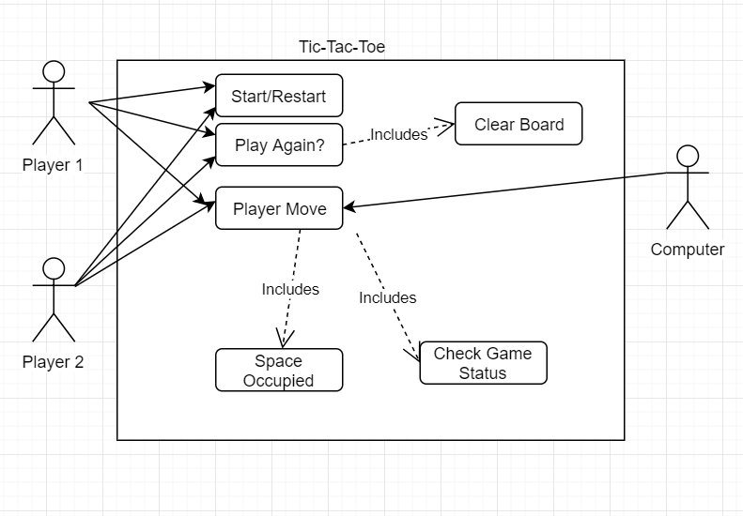

The problem given was to use HTML, CSS, and JavaScript (without the jQuery library) and make a Tic-Tac-Toe board game.

We were told to create a board with empty game cells, and to format the game to follow the rules of Tic-Tac-Toe on a 3x3 board. The user’s goal is to get three in a row. The program will alternate between X and O, starting with either (chosen at random) and displaying, under the table, “It is X’s turn” or “It is O’s turn.” Then using the DOM and the click event, a script must be written that allows the user to place their game piece into the cell they click. The program determines when the game is over and prompts the user to determine whether to play again (using buttons). The buttons “Start/Restart” and “Play Again?” appear available, with the “Play Again?” button only being available when a game is over (either due to a win/loss or “the cat’s game.” Then the Math. Random method to determine if X or O plays first at the beginning of a game. Then the program allows a user to quit the current game and start a new game (“Start/Restart”). Then the program allows the user to select what mode to play (Player v Player, Player v Computer) If the game is a “Player v Computer”, the Player always gets X and the Computer always gets the O symbol, but who moves first depends on the randomization just as it would if it was Player v Player. Then the program also records and displays the amount of time the game has been played for. And lastly the program needs to work on Microsoft Edge, Mozilla Firefox, and Google Chrome platforms.

I broke it up with HTML first by deciding where I wanted my game board, timer, game counter, and buttons. From there I drew out on paper how I wanted the layout to be. Then from that I investigated potential styles (fonts, colors, etc.) that I wanted to implement into the program. Then after ensuring that the board was adjustable on the screen and the page loaded as it was expected to, I moved onto the JavaScript. In the JavaScript, I created algorithms to handle Wins, Draws, AI movement, resetting the board, toggling between players, handling each square and calculating if the game was over. Then I implemented that into the website through calls set by the clicks, which allowed the board to have some real-time functionality.

This is the first time I’ve ever really done anything with JavaScript, and it was a wonderful!